**Microbial Electrosynthesis Systems (MES)**

**Background**

Microbial electrosynthesis systems (MES) are a technology for simultaneous removal of chemical oxygen demand (COD) or impurity in wastewater in anode chamber and synthesis of products in cathode chamber by harnessing oxidation and reduction (redox) reactions by the application of an electric field between an anode (positive electrode) and a cathode (negative electrode). Electrogenic bacteria harvest electrons utilising organic or heavy metal impurity present in wastewater as substrate in anode chamber. This way, COD of wastewater can be lowered. Organic if present in wastewater as impurity can be oxidised into carbon dioxide/biocarbonate ion, proton and electron, while heavy metals if present in wastewater as impurity can be oxidised into metal cation and electron in the anode chamber. These are flown to the cathode chamber. Carbon dioxide/biocarbonate ion can be reduced in the cathode chamber in the presence of proton to synthesise volatile fatty acids, of which, formic acid, acetic acid, propionic acid, butyric acid, valeric acid and caproic acid are the products of interest from MES. Alternatively, if metal cations are generated from wastewater with heavy metal impurity in the anode chamber, they combine with electrons or can be reduced for the recovery of metals in the cathode chamber. The process offering such redox reactions are known as MES. Figure 1 shows MES schematic.

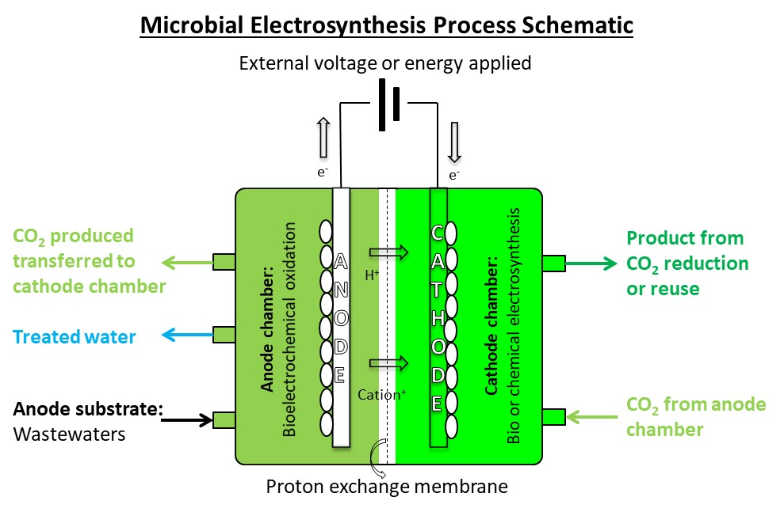

Figure 1. MES schematic for CO2 reduction or reuse into product synthesis.

**Steady state overall reaction equation based model**

This section focuses on the mass and energy performance analysis based on the assumption of an overall reaction equation for the MES. The analysis results are related to the analysis of environmental performance such as global warming potential impact using a life cycle assessment approach and techno-economics. The overall reaction of MES for carbon dioxide reduction or reuse into product synthesis can be presented as in Equation 1.

$x'C_{x}H_{y}O_{z} +mH_{2}O = C_{c}H_{h}O_{o}+m'H_{2}$ Equation 1

The organic substrate in the anode chamber has a chemical formula of $C_{x}H_{y}O_{z}$, where *x*, *y* and *z* indicate the number of carbon, hydrogen and oxygen atoms, respectively, in 1 mole of substrate. The chemical product in the cathode chamber has a chemical formula of $C_{c}H_{h}O_{o}$, where *c*, *h* and *o* indicate the number of carbon, hydrogen and oxygen atoms, respectively, in 1 mole of product.

x', m and m’ are stoichiometric coefficients of substrate, water and hydrogen, respectively, in Equation 1.

From desired product formula and analysed substrate formula, the stoichiometry of the overall reaction in equation 1 can be established, shown in Equations 2-4.

From carbon balance: $x^{'}=\frac{c}{x}$ Equation 2

From oxygen balance: $m=o-\frac{cz}{x}$ Equation 3

From hydrogen balance: $m^{'}= \frac{1}{2}(-h+\frac{cy}{x}+2o-\frac{2cz}{x})$ Equation 4

For a given concentration of anode substrate $Cs$ in g/L, volumetric flowrate of wastewater $V$ in L/h and fractional conversion of the substrate, $μ$, the production rate in g/h can be estimated using Equation 5. $Cs$, $V$ and $μ$ are therefore user inputs that can be varied to conduct sensitivity analysis of their impacts on the outputs in Equations 6-7. Atomic mass of carbon, hydrogen and oxygen are 12, ~1 and 16, respectively.

Production rate (g/h) = $\frac{Cs×V×μ×(12c+h+16o)}{x^{'}(12x+y+16z)}$ Equation 5

COD and concentration of substrate $Cs$ in g/L are inter-related by Equation 6. Equation 6 is needed to transform between known COD of anode wastewater substrate and concentration of model compound for anode substrate.

Initial COD (g) = $\frac{Cs×16×(12x+0.5y-z)}{(12x+y+16z)}$ Equation 6

The energy input to MES needs to be calculated for the estimation of the theoretical potential to MES and the global warming potential to be saved by the MES. The standard Gibbs energy of reaction (kJ/mol substrate) can be estimated from the standard Gibbs free energy of formation of product $∆G_{f}^{0}\left(p\right)$ (in kJ/mol), subtracted by the standard Gibbs free energy of formations of substrate $∆G_{f}^{0}\left(s\right)$ (in kJ/mol) and water (-237.13 kJ/mol) as shown in Equation 7. $p$ and $s$ within the first bracket indicate product and substrate, respectively.

Standard Gibbs energy of reaction (kJ/mol substrate) = $\frac{1}{x^{'}}(∆G_{f}^{0}\left(p\right)-x^{'}×∆G_{f}^{0}\left(s\right)-m×\left(-237.13\right))$ Equation 7

Equation 8 relates the Gibbs energy of reaction with the theoretical potential (Voltage).

Theoretical potential (V) = $-\frac{Standard Gibbs energy of reaction (kJ/mol substrate) }{96485×number of electrons transferred in the overall reaction}$ Equation 8

To estimate the global warming potential to be saved by the MES, an average global warming potential from the production of the product, the service that would be displaced) should be subtracted by the global warming potential of the energy required by the MES for the synthesis of the product. The global warming potential saving by the MES thus can be estimated at the standard condition (25oC and 1 atm), as shown in Equation 9.

Global warming potential saving by MES (g CO2 equivalent/h) = $GWP\left(p\right)×Production rate (g/h)-GWP\left(E\right)×Standard Gibbs energy of reaction (kJ/h)$ Equation 9

$GWP\left(p\right)$ is the average global warming potential from the production of the product in g CO2 equivalent/g product. $GWP\left(E\right)$ is the global warming potential of the energy supplied to the MES in g CO2 equivalent/kJ energy supplied.

The Gibbs energy of reaction is converted from kJ/mol substrate to kJ/h using Equation 10.

Standard Gibbs energy of reaction (kJ/h) = Standard Gibbs energy of reaction (kJ/mol substrate) $×\frac{Cs×V×μ}{x^{'}(12x+y+16z)}$ Equation 10

**Techno-economic assessment**

This section discusses the estimation of capital cost of MES and the discounted cash flow analysis over the life cycle of MES1. The capital cost is estimated using Equation 11. In order to arrive at this equation, first the delivered cost of one cell is estimated by the summation of that of each component in the cell, i.e. anode, cathode, membrane and current collector2. Individual delivered costs are adjusted for the estimated production rate from a given production rate2. Two cells are to be installed for a continuous mode of operation, following the principles of fluidised bed catalytic cracking operations in crude oil refineries1, wherein one unit operates until it need regeneration, while the other unit is regenerated until it is ready for operation2. A Lang factor is then applied to estimate the capital cost1-2.

Capital cost = $(\sum_{i}{{DC}_{i}×\frac{{base size}_{i}}{{base production rate}_{i}})×Production rate}×2×Lang factor$ Equation 11

${DC}_{i}$ is the delivered cost of each component $i$ in a cell, $i∈anode, cathode, membrane, current collector$. ${base production rate}_{i}$ is the production rate in the same unit as the present production rate (Equation 5) for the known base size of the component $i$ in the cell. Production rate estimated using Equation 5 can be transformed into an appropriate unit, e.g. kg/year, depending on the unit of the ${base production rate}_{i}$.

The net present value (${NPV}_{y}$) in a given year $y$ of the MES operation is calculated using Equation 123.

Equation 12

$${NPV}_{y=0}=Capital cost$$

$IRR$ is the internal rate of return in fraction. $Capex$ is an $Annual Capital Charge$ applied to the Capital cost (Equation 13). $Opex$ is the operating cost, the summation of the fixed operating cost dependent on the indirect annual capital cost, labour dependent fixed operating cost and the cost of utilities, applied with a multiplier (Equation 14)1. The indirect annual capital cost is dependent on the delivered cost of equipment (Equation 15). The labour dependent fixed operating cost is a function of the production rate of the MES (Equation 16). The cost of utilities include the costs of catholyte, anolyte and external electricity (Equation 17).

$Capex= Annual Capital Charge×Capital cost$ Equation 13

$Opex=a ×(fixed operating cost dependent on indirect annual capital cost ×b+ labour dependent fixed operating cost+cost of utilities)$ Equation 14

$fixed operating cost dependent on indirect annual capital cost= \frac{Capital cost}{Lang factor}×Annual Capital Charge$ Equation 15

$labour dependent fixed operating cost=c×Production rate$ Equation 16

$a, b and c$ are multipliers of the respective cost components to account for a larger set of cost components3.

Equation 17

where, $i^{'}∈anolyte,catholyte, electricity$

$Product value$ in Equation 12 is the multiplication between the price of the product and the production rate (Equation 18).

$Product value=Price of product ×Production rate$ Equation 18

**Case study**

The overall reaction based steady state model of MES described in Equations 1-10 are exemplified using a model substrate compound for anode and desired products in cathode. Table 1 shows the relevant input data for some model substrates in anode.

Table 1. Relevant physicochemical and thermochemical data of model substrate compounds in anode. Molar mass and COD are the calculated values.

|  |  |  |  |  |  |  |  |
| --- | --- | --- | --- | --- | --- | --- | --- |
| Anode substrate (s) | *x* | *y* | *z* | (kJ/mol)3 | *molar mass* | *COD, g/mol* | *g COD/g* |
| Acetate | 2 | 3 | 2 | -369.31 | 59 | 56 | 0.95 |
| Glucose | 6 | 12 | 6 | -910 | 180 | 192 | 1.07 |
| Lactate | 3 | 5 | 3 | -516.6 | 89 | 88 | 0.99 |
| Pyruvate | 3 | 3 | 3 | -474.5 | 87 | 72 | 0.83 |
| Sucrose | 12 | 22 | 11 | -1551.8 | 342 | 384 | 1.12 |

Table 2 shows desired cathode products with relevant input data.

Table 2. Input data for cathode products of choice.

|  |  |  |  |  |  |  |
| --- | --- | --- | --- | --- | --- | --- |
| Cathode product (p) | *c* | *h* | *o* | (kJ/mol)3 | kg CO2 eq./kg4 | *molar mass* |
| Acetic acid | 2 | 4 | 2 | -299.78 | 1.7 | 60 |
| Butyric acid | 4 | 8 | 2 | -282.94 | 2.88 | 88 |
| Caproic acid | 6 | 12 | 2 | -266.1 | 2 | 116 |
| Formic acid | 1 | 2 | 2 | -278.8 | 2.8 | 46 |
| Propionic acid | 3 | 6 | 2 | -291.36 | 2 | 74 |
| Valeric acid | 5 | 10 | 2 | -344.2 | 2 | 102 |

Equations 2-9 are exemplified using acetate as anode model substrate, as shown in Tables 3 and 4. Table 3 shows the calculated outputs of Equations 2-4 and 7-8, for acetate as the chosen substrate and the cathode products of choice shown in Table 2.

For the following values, concentration of anode substrate $Cs$ = 1 g/L, volumetric flowrate of wastewater $V$ = 1 L/h and fractional conversion of the substrate $μ$ = 0.7, Table 4 shows the calculated outputs of Equations 5 and 9, for acetate as the chosen substrate and the cathode products of choice shown in Table 2. $GWP(E)$ is calculated using equal proportions of all energy source or technology options and the factors applied for the estimation of the GWP of the UK grid electricity mix5 (Table 5)

Table 3. Outputs of Equations 2-4 and 7-8, for acetate as the chosen substrate and the cathode products of choice shown in Table 2.

|  |  |  |  |  |  |  |
| --- | --- | --- | --- | --- | --- | --- |
| Anode substrate: | Acetate |  |  |  |  |  |
| Cathode product | Acetic acid | Butyric acid | Caproic acid | Formic acid | Propionic acid | Valeric acid |
|  |  |  |  |  |  |  |
| x' | 1 | 2 | 3 | 0.5 | 1.5 | 2.5 |
|  |  |  |  |  |  |  |
| m | 0 | -2 | -4 | 1 | -1 | -3 |
|  |  |  |  |  |  |  |
| m' | -0.5 | -3 | -5.5 | 0.75 | -1.75 | -4.25 |
|  |  |  |  |  |  |  |
| Standard Gibbs energy of reaction (kJ/mol substrate) | 69.53 | -9.29 | -35.56 | 285.97 | 16.98 | -52.926 |
|  |  |  |  |  |  |  |
| Theoretical potential (V) | 0.24 | -0.05 | -0.37 | 0.85 | 0.07 | -0.37 |

Table 4. Outputs of Equations 5 and 9, for acetate as the chosen substrate and the cathode products of choice shown in Table 2, and concentration of anode substrate = 1 g/L, volumetric flowrate of wastewater = 1 L/h and fractional conversion of the substrate = 0.7.

|  |  |  |  |  |  |  |
| --- | --- | --- | --- | --- | --- | --- |
| Anode substrate: | Acetate |  |  |  |  |  |
| Cathode product | Acetic acid | Butyric acid | Caproic acid | Formic acid | Propionic acid | Valeric acid |
|  |  |  |  |  |  |  |
| Production rate (g/h) | 0.71 | 0.52 | 0.46 | 1.09 | 0.59 | 0.48 |
|  |  |  |  |  |  |  |
| Global warming potential saving by MES (g CO2 equivalent/h) | 1.14 | 1.51 | 0.95 | 2.75 | 1.15 | 1.02 |

Table 5. $GWP(E)$ of energy source or technology options5.

|  |  |
| --- | --- |
|  | kg CO2 equivalent/MJ |
| CCGT | 0.1386 |
| Nuclear | 0.0081 |
| Biomass | 0.0125 |
| Coal | 0.2467 |
| Wind | 0.0072 |
| Solar | 0.0236 |
| Oil | 0.2036 |
| OCGT | 0.1386 |
| Hydroelectric | 0.0072 |
| Pumped hydro | 0.1153 |
| Other | 0.0758 |

The techno-economic analysis model shown in Equations 11-18 is applied to the combinations, anode substrate = acetate and the cathode products of choice in Table 2. The user input variables for the techno-economic analysis model are shown in Table 6.

Table 6. User input parameters for techno-economic analysis2.

|  |  |  |  |
| --- | --- | --- | --- |
| **Delivered cost** | **Default** | **Unit** | **Range** |
| Anode | 15 | Euro/m2 | 5-20 |
| Cathode | 15 | Euro/m2 | 5-20 |
| Membrane | 440 | Euro/m2 | 10-500 |
| Current collector | 28 | Euro/m2 | 10-30 |
|  |  |  |  |
| Lang factor | 4.75 |  | 1.5-5 |
|  |  |  |  |
| **Variables for NPV calculations** |  |  |  |
| $$Annual Capital Charge$$ | 0.13 |  | 0.05-0.15 |
| IRR | 0.12 |  | 0.05-0.15 |
|  |  |  |  |
| **Price of utility** |  |  |  |
| Anolyte | 0.0012 | Euro/m3 | 0.001-0.002 |
| Catholyte | 0.5 | Euro/m3 | 0.1-1 |
| Electricity | 0.15 | Euro/kWh | 0.05-0.2 |
|  |  |  |  |
| **Product price** | 0.024 | Euro/g | 0.01-1 |

${DC}_{i}$ = 0.0016 m2 for anode, cathode and membrane for a ${base production rate}_{i}$ = 0.1 kg/year, while ${DC}_{i}$ = 0.0005 m2 for current collector for the same 2. These values are applied in Equation 11 to estimate the capital costs of the various combinations: anode substrate = acetate and the cathode products of choice in Table 2, as shown in Table 7.

Table 7. Estimated capital cost using Equation 11 for acetate as the chosen substrate and the cathode products of choice shown in Table 2, and concentration of anode substrate = 1 g/L, volumetric flowrate of wastewater = 1 L/h and fractional conversion of the substrate = 0.7.

|  |  |  |  |  |  |  |
| --- | --- | --- | --- | --- | --- | --- |
| Anode substrate: | Acetate |  |  |  |  |  |
| Cathode product | Acetic acid | Butyric acid | Caproic acid | Formic acid | Propionic acid | Valeric acid |
| Capital cost, Euro | 18.91 | 13.87 | 12.19 | 28.99 | 15.55 | 12.86 |

For Equations 14 and 16, dimensionless $a, b and c$ multiplier values are: 1.3, 0.19 and 0.09 (when the product rate is in g/h), respectively1. The consumption rate of anolyte and catholyte can be estimated proportionally for the present production rate based on the following data: a cell volume of 0.29 L gives a ${base production rate}_{i}$ = 0.1 kg/year (Equation 17). Equations 13-18 further use the input data in Table 6. The discounted cash flow (Equation 12) with respect to year over the MES life is estimated for acetate as the model substrate of anode and formic acid as the product of choice from cathode, as shown in Figure 2.

Figure 2. Discounted cash flow analysis for acetate as the model substrate of anode and formic acid as the product of choice from cathode of MES.

**References**

1. Sadhukhan, J. Ng, K.S. and Martinez-Hernandez, E., 2014. *Biorefineries and Chemical Processes: Design, Integration and Sustainability Analysis*. Wiley, Chichester, UK.
2. Shemfe, M., Gadkari, S., Yu, E., Rasul, S., Scott, K., Head, I.M., Gu, S. and Sadhukhan, J., 2018. Life cycle, techno-economic and dynamic simulation assessment of bioelectrochemical systems: A case of formic acid synthesis. *Bioresource technology*, *255*, pp.39-49.
3. Sadhukhan, J., Lloyd, J.R., Scott, K., Premier, G.C., Eileen, H.Y., Curtis, T. and Head, I.M., 2016. A critical review of integration analysis of microbial electrosynthesis (MES) systems with waste biorefineries for the production of biofuel and chemical from reuse of CO2. *Renewable and Sustainable Energy Reviews*, *56*, pp.116-132.
4. Extracted from SimaPro 9 Ecoinvent 3.6.
5. <https://gridwatch.co.uk/co2-Emissions>